Tampere Tramway Ltd.
Contact: Ali Huttunen
Email: ali.huttunen@tampereenraitiotie.fi
Please fill in the sections indicated with colour grey only. Do not change any other content.
Organisational details
Organisation | Organisation's full name (short name)
Organisation description | Please provide a brief description (4–5 lines) of the organisation's business activities and its areas of operation, products and services, main markets, personnel and ownership base. Also, please indicate potential connection to a larger group.
Address | Give address here
Web | Give internet address here
Country | Country where the organisation is registered
VAT number | VAT number, if any
Contact | Name, job title and organisational unit, e-mail and visiting address, telephone
Membership category  (See appendix 1)  (Tick the relevant box) | Large enterprise Small enterprise University or university of applied sciences  Mid-cap company Microenterprise Foundation, association, trade organisation  Mid-size enterprise Start-up enterprise Research institute  Other organisation City or city-owned company Public sector org.

Our priority areas in development, testing, validation and collaboration related to the Lyyli Living Lab
Please describe briefly the main areas of your product, service and/or digitalisation development in which you intend to use the TURMS-Innovation cluster and Lyyli Living Lab- RDI environment.

Partnership of Lyyli Living Lab-RDI environment and TURMS-Innovation cluster
Lyyli Living Lab and the coordinator of its activities TURMS (Tampere Urban Rail Mobility Services) – Innovation cluster is a globally open development and validation environment involving various interest groups for tram technology and city transport/mobility services related to the tram environment, including digital services. Lyyli Living Lab is built around the City of Tampere tram system, including a test tram, other tramcars as applicable, depot, stops and their auxiliary systems, developer portal, data integration platform and end-user feedback system. The anticipated life cycle of Lyyli Living Lab is at least six years (2023–2028).
Business Finland (BF) is funding Lyyli Living Lab operations between 5.4.2022 – 31.12.2025. The funding provided by BF is referred to as Innovation Cluster Funding. An existing committed organisational group is required to receive Innovation Cluster Funding (a cluster is formed by companies, universities and research institutes, the public sector, foundations, organisations, etc.). The commitment is demonstrated through annual TURMS-Innovation cluster Partnership fees. Maximum amount of BF funding is equal with Partnership fees collected from the members. Innovation Cluster Funding and Partnership fees are used for the development and marketing of the Lyyli Living Lab. Operative development, testing, validation and other activities in TURMS are carried out by the Partners themselves and at their own expense. Partners are allowed, if desired, to utilize TURMS chargeable services (installation assistance and monitoring, security inspections and permits, etc.; see TURMS Rulebook).
Our organisation finds Lyyli Living Lab-RDI environment and TURMS-Innovation cluster as a unique opportunity to accelerate and improve the development process of our products and we commit ourselves to TURMS innovation cluster partnership under the following terms and conditions.

Commitment period (tick the relevant years and complete the total duration in years; min. 1 year + 1 year's steps)
2023 | 2024 | 2025 | 2026 | 2027 | 2028

Commitment period | N | years

Partnership fee (see Appendix 1 for the current annual fees) | Total  [€]
Partnership fee for the entire commitment period | 0
The annual partnership fee varies depending on the commitment period and the size/type of the organisation. Please select the appropriate partnership fee category and multiply the indicated annual fee by the total duration of commitment.
The partnership fee is collected annually at the beginning of the partnership period. The partnership period may begin from the beginning of the agreed month in the middle of the calendar year.
In exchange for the partnership fee, the partners get:
- A real-life development and test environment for urban mobility products and services.
- A development environment involving different user groups with feedback systems.
- Visibility and access to references in a unique urban Living Lab.
- A networking environment for encounters with partners and new business openings.
- Access to mutually compatible urban transport information resources (Lyyli test tram, tram fleet, feeder traffic, rail network, stops, depot, etc.).
- The TURMS partner days each year, and active communication about TURMS events and the opportunity to influence their content.
- TURMS-Innovation cluster annual fees and service charges are considered eligible costs in projects funded by Business Finland.

With this application, we register as a partner in the TURMS-Innovation cluster led by Tampere Tramway Ltd.
We have acquainted ourselves with the TURMS Rulebook and are committed to complying with the rules and principles outlined therein.
Our registration will take effect on the date specified below upon the signature of an authorised signatory, and our partnership will be valid for the commitment period specified above.
Best regards,
Place and date

______________________________________
Print name of the authorised signatory
Job title
Organisation

Organisational categories and annual partnership fees
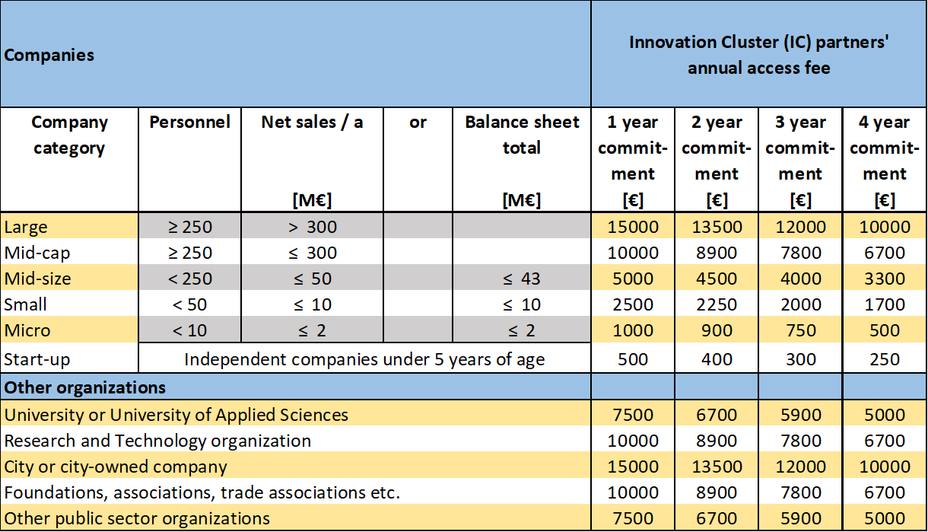
The table presents only the fees based on one or more years' commitment. There are also plans for a pricing model per test day for stakeholders not willing to engage in an annual partnership. This kind of charge is still under consideration, but it could be defined so that after 1–2 days of testing it amounts to the same level as the annual fee.

